Procedural enemy waves planning document

**Enemy Spawning Strategy Overview**

To maintain a consistent and engaging challenge throughout gameplay, the enemy spawning system in *Crystal Defenders: The Last Stand* is built around a dynamic adaptive model. Instead of relying on fixed spawn numbers per wave, the system evaluates the current state of the battlefield, including player resources, tower health, defender performance, and kill efficiency, to decide what type of enemies to deploy and at what intensity. This ensures that each wave feels unique and directly responsive to the player's play style and overall performance.

**Difficulty Scaling Logic**

Enemy difficulty increases gradually using wave-based scaling, where each new wave increases enemy health and count while slightly reducing spawn intervals to increase pressure. However, to prevent unfair difficulty spikes, adaptive difficulty checks act as a safety net. For example:

* If the base tower is below 50% health, the number of enemies spawned is reduced, and their spawn timing is delayed.
* If the player has over 400 unspent resources, it is inferred that defenses are strong, so additional enemies may spawn, or Fast UFO units may begin appearing sooner.
* If defenders are damaged or destroyed, the game temporarily halts the introduction of advanced enemy classes, allowing the player time to recover.

This creates a rubber-band difficulty effect that keeps gameplay tense but never overwhelming.

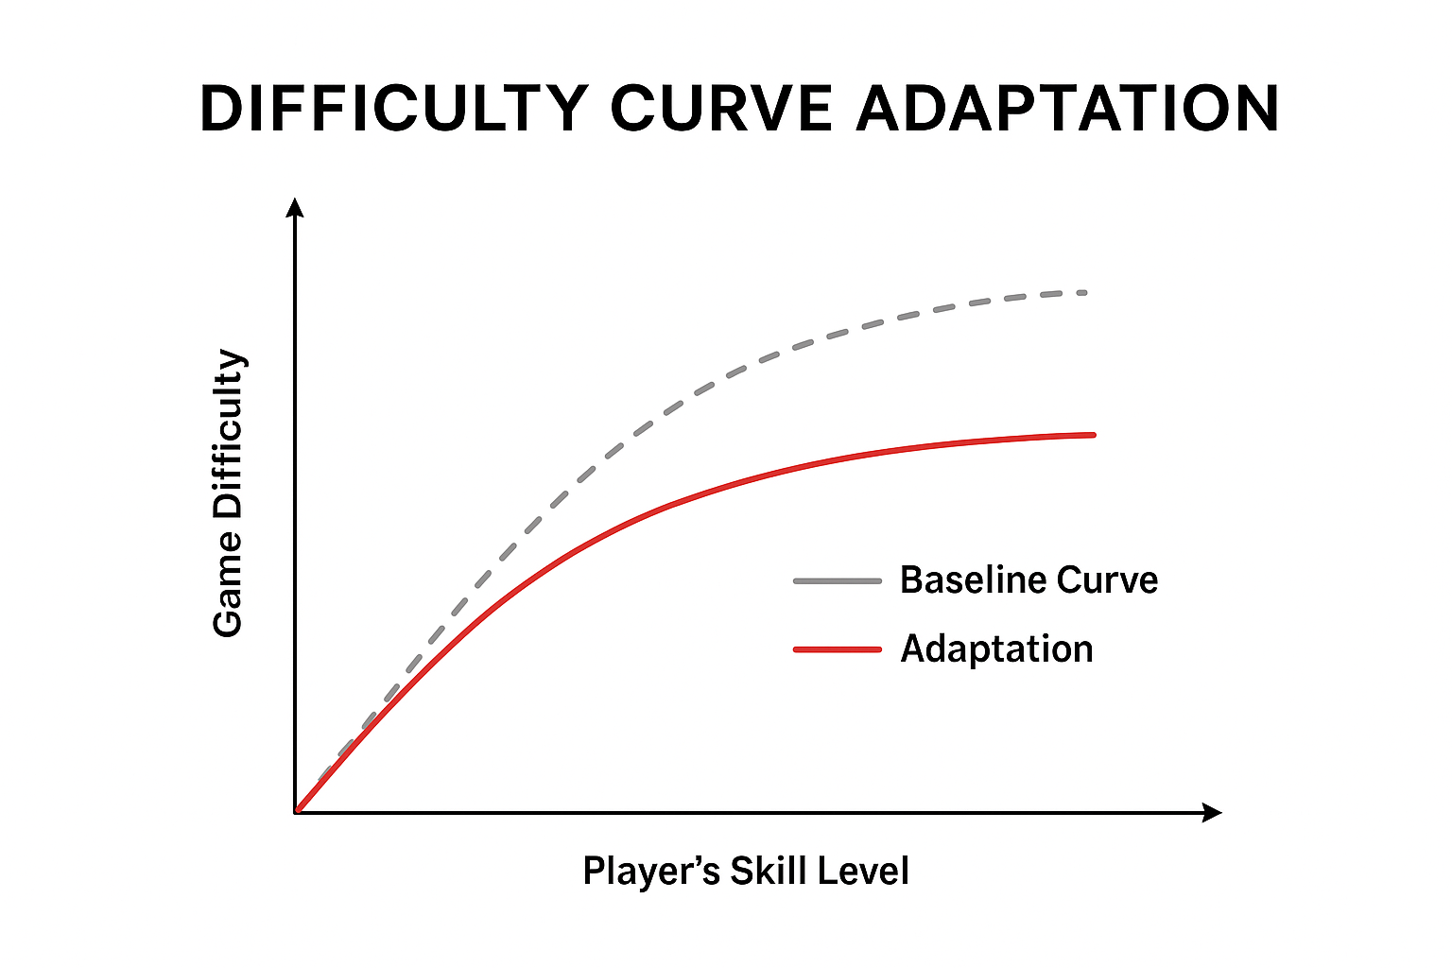

Figure 1: ChatGPT. [SA]. *Difficulty Curve Adaptation*. (ChatGPT, 2025)

**Adaptive Response to Player Skill**

The game tracks how efficiently the player clears enemies. If basic enemies are being destroyed too quickly, it signals that the player has a strong defense setup. In this case:

* Fast enemies are introduced earlier to challenge target prioritization.
* Ranged UFO attackers appear more frequently to apply pressure from a distance and force tower repositioning.
* Enemy mix variety increases, breaking predictable patterns and forcing the player to respond dynamically.

However, if the game detects that waves are surviving too long or consistently reaching the base, it reduces the chance of spawning complex enemy types and temporarily increases basic enemy frequency to prevent frustration.

**Spawn Location Determination**

Multiple spawners are placed across the map at strategic path entry points. Instead of spawning enemies at a fixed coordinate, each spawn point applies a slight randomized offset using perpendicular vector calculations based on the first two nodes of the enemy path. This prevents units from spawning in a single file and creates a natural staggered formation, making tower targeting less predictable and visually more engaging.

**Enemy Type Selection Strategy**

Enemy selection uses a weighted probability system. At early wave levels, Default Enemies hold majority weight to give the player time to establish defenses. As waves progress:

* Fast UFOs gain more weight if defender kill rate is high.
* Ranged UFO attackers gain weight if tower health remains untouched for multiple waves.
* Delayed counters are used if the player has no poison towers built, poison-resistant enemies are held back to avoid unfair matchups.

This ensures tactical fairness while still rewarding players who plan ahead and diversify their defenses.

**Final Goal**

The goal of this system is not simply to increase enemy numbers but to introduce meaningful tactical shifts that evolve the battle rhythm. Each wave should tell a story starting with probing forces, escalating into mixed pressure squads, and finally evolving into specialized threats that test the player's strategic depth.

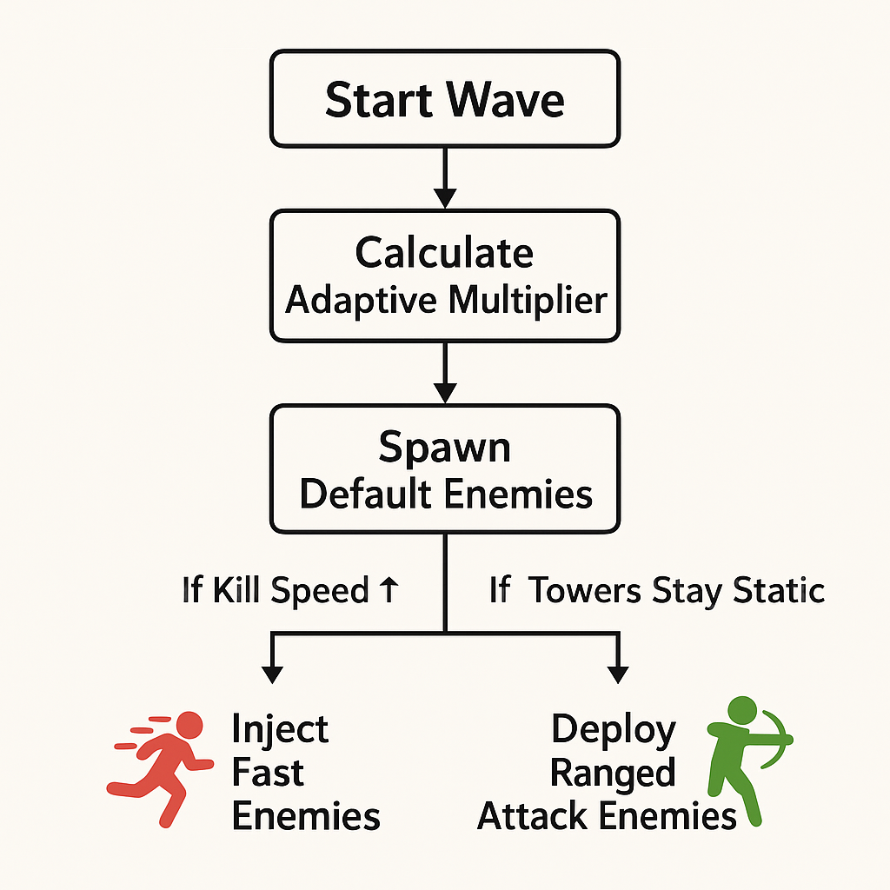

Figure 2: ChatGPT. [SA]. *enemy composition diagram*. (ChatGPT, 2025)

# References

ChatGPT, 2025. *Diagram – Difficulty Curve Adaptation.* [Online]   
Available at: <https://chatgpt.com>  
[Accessed 15 October 2025].

ChatGPT, 2025. *enemy composition diagram.* [Online]   
Available at: <https://chatgpt.com>  
[Accessed 15 October 2025].

List of Figures:

Figure 1: ChatGPT. [SA]. *Difficulty Curve Adaptation*.

Figure 2: ChatGPT. [SA]. *enemy composition diagram*.